**WEEK – 4 Assignments**

**ASP. NET Core 8. 0 Web API**

**Mandatory hands-on :-**

**2. WebApi_Handson :**

**Objectives:**

· Demonstrate Swagger installation to WebAPI and WebAPI listing on browser

o Nuget package to download Swashbuckle.AspNetCore, Usage of ProducesResponseType to Web API method, AddSwaggerGen, UseSwaggerUI

· Demonstrate the usage of Postman tool to hit WebAPI methods

o Structure in Postman tool, Headers with Authorization, Body as JSON, Option to choose the type of request, Request collection and how to add a new request in the collection, Tabs in the center pane that corresponds to the request

· Demonstrate the usage of Route and Explain Name attribute in Http requests

o Importance of user friendly name to action method, Explain the usage of ActionName to have more than 1 method with the same Action verbDemonstrate creation of a simple WebAPI - With Read, Write actions.

**1. Web Api using .Net core with Swagger**

[**Employee.cs**](http://employee.cs) **:**

| **public class Employee {  public int Id { get; set; }  public string Name { get; set; } }** |
| --- |

[**Program.cs**](http://program.cs) **:**

| **using Microsoft.OpenApi.Models;  var builder = WebApplication.CreateBuilder(args);  // Add services to the container. builder.Services.AddControllers(); builder.Services.AddSwaggerGen(c => {  c.SwaggerDoc("v1", new OpenApiInfo  {  Title = "Swagger Demo",  Version = "v1",  Description = "TBD",  TermsOfService = new Uri("https://example.com/terms"),  Contact = new OpenApiContact  {  Name = "John Doe",  Email = "john@xyzmail.com",  Url = new Uri("https://www.example.com")  },  License = new OpenApiLicense  {  Name = "License Terms",  Url = new Uri("https://www.example.com")  }  }); });  var app = builder.Build();  // Configure the HTTP request pipeline. app.UseSwagger(); app.UseSwaggerUI(c => {  c.SwaggerEndpoint("/swagger/v1/swagger.json", "Swagger Demo"); });  app.UseAuthorization(); app.MapControllers(); app.Run();** |
| --- |

[**EmployeeController.cs**](http://employeecontroller.cs) **:**

| **using Microsoft.AspNetCore.Mvc; using System.Collections.Generic; using System.Linq;  [Route("api/Emp")] [ApiController] public class EmployeeController : ControllerBase {  private static List<Employee> employees = new List<Employee>  {  new Employee { Id = 1, Name = "Divyanshu" },  new Employee { Id = 2, Name = "Prateek" }  };   [HttpGet]  [ProducesResponseType(typeof(IEnumerable<Employee>), 200)]  public ActionResult<IEnumerable<Employee>> Get()  {  return Ok(employees);  }   [HttpPost]  [ProducesResponseType(typeof(Employee), 201)]  public ActionResult<Employee> Post([FromBody] Employee emp)  {  emp.Id = employees.Count + 1;  employees.Add(emp);  return CreatedAtAction(nameof(Get), new { id = emp.Id }, emp);  } }** |
| --- |

**OUTPUT (Swagger):**

**GET : api/Emp :**

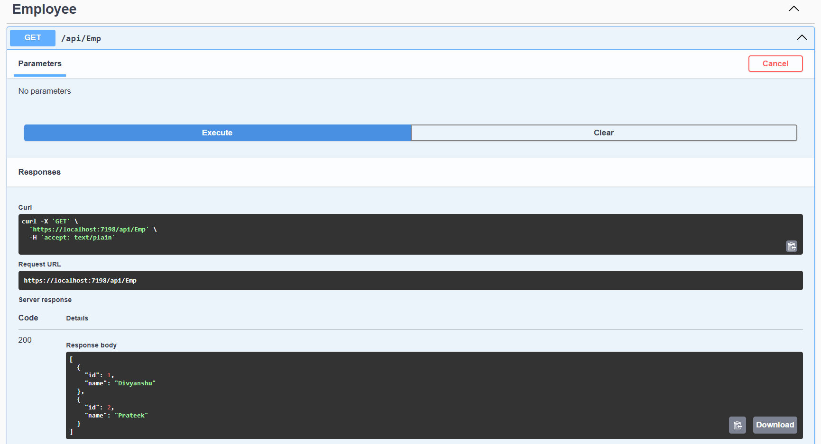

**POST : api/Emp :**

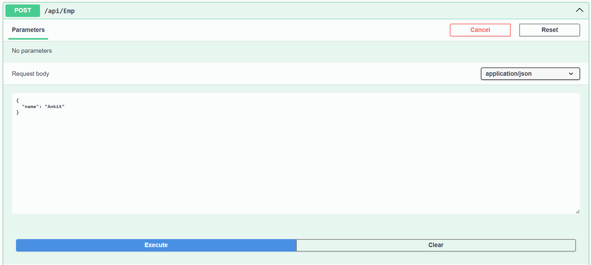

**POST : api/Emp :**

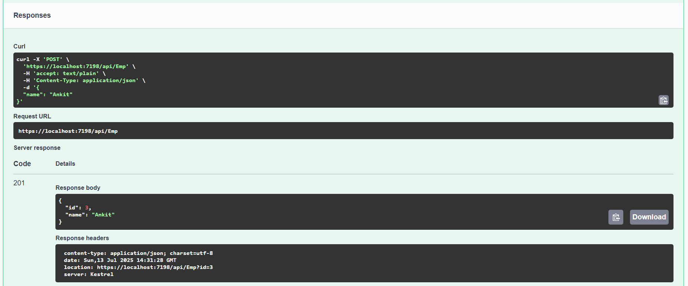

**OUTPUT (POSTMAN) :**

**GET : api/Emp :**

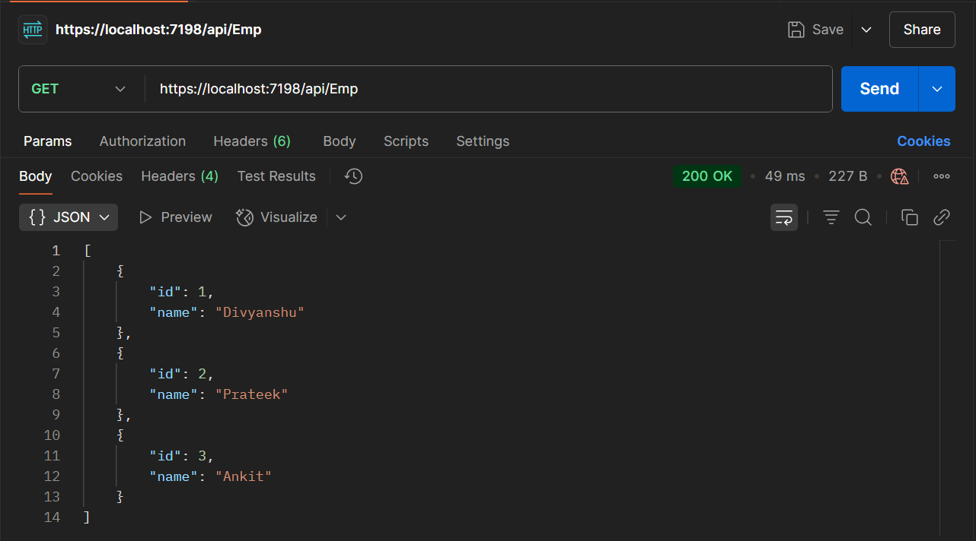

**POST : api/Emp :**

